

**Green University of Bangladesh**

**Department of Computer Science and Engineering (CSE)**

#### Faculty of Sciences and Engineering Semester: (Spring, Year:2022), B.Sc. in CSE (Day)

#### Course Title: Structured Programming Course Code: CSE-104 Section: DE

#### Lab Project Name: Doctor Appointment System

#### Student Details

|  |  |
| --- | --- |
| **Name** | **ID** |
| **Md. Shipon Miah** | **213902104** |

#### Submission Date : 10 / 05 / 2022

#### Course Teacher’s Name : Md. Parvez Hossain

#### [

**Lab Project Status**

**Marks: …………………………………**

**Signature: .....................**

**Comments: ..............................................**

**Date: ..............................**

Table of Contents

Chapter 1 Introduction 3

* 1. Introduction 3
  2. Design Goals/Objective 3

Chapter 2 Design/Development/Implementation of the Project 4

* 1. Interface 4
  2. Algoritham 4

Chapter 3 Performance Evaluation 07

* 1. Results and Discussions 08
  2. Results and Discussions 09
  3. Analysis and outcomes 10

Chapter 4 Conclusion 11

4.1 Introduction 11

* 1. Practical Implications 11
  2. Scope of Future Work 11

# Chapter 1 Introduction

## Introduction

The Doctor Appointment System has been developed to override the problems of prevailing in the practicing manual system. The Application is reduced as much as possible to avoid errors while entering the data. These system will ultimately allow you to better manage recourses.

## Design Goals/Objective

* + - The main focus of this project is to reduce time and lessen human efforts.
    - To provide a user-friendly environment where a user can be serviced better easy.
    - To gathers all the valuable patient-related information on a single platform, enables quick retrieval of essential data, and filters their availability by the access level.
    - To replace a complex net of educational bureaucracy and provide efficient communication channels on all levels.
    - To keep all the information organized and keep them in a batter place, and reduce the chance of mistake.

**Chapter 2**

* **Doctor Appointment System**

The Doctor Appointment System I made using C program will be look like this.

#### Interface

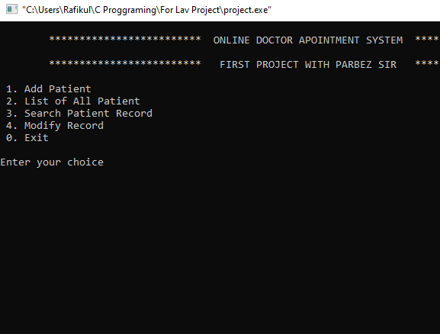

Figure 2.1

* 1. **Algorithm**

.

**Step 1:** Start.

**Step 2:** Declare a Structure data type named student to store different types of variables under a single datatype.

**Step 3:** Declare 4-character type array named as jId [30], name [10], gender [10],

blood group [19] Diases[10], number[15].

**Step 5:** Named a function called add ().

**Step 5.1:** In the definition of the function, We get the information of a patient Id, Name, gender,blood group, deases and phone_no from users using gets() library function

**Step 5:** Named a function called modify ().

**Step 6.1:** In the definition of the function, read patient Id, Name, gender,blood group, deases ,phone_no and check the that if it’s match any of the patients information. Then update the information by getting new value from user.

**Step 8:** Named a function called search ().

**Step 8.1:** In the definition of the function, we read the information about that patient and then if those information match any of the value in the variable then

**Step 8.2**: Print the value of that patient. And if the information didn’t match then it will print that “The Search Information not found on the record”

**Step 9:** Named a function called records ().

**Step 10**: In the definition of the function, we show all the data that has been admitted.

**Step 12:** In the main function we show users the option which he wants to work on.

* 1 for Admit Patient
* 2 for List of all patient
* 3 for Search patient record
* 4 for Modify.
* 0 for exit.

**Step 12.1**: Get a choice from users.

**Step 13:** Use a switch case with the value from users.

**Step 13.1:** case ‘1’ then check if (l==size) then if that condition didn’t match then call the add () function. That function will do its work then break;

**Step 13.2:** case ‘2’ then if (l==0){ print the all patient list if is empty; and break;} then call all patient list () function and then break.

**Step 13.3:** case ‘3’ then if (l==0) {print the record list is empty; and break;} then call the search () function and then break.

**Step 13.4**: case’5’ then if (l==0) {print the record list is empty; and break;} then call the modify () function and then break.

**Step 13.6:** case ‘0’ then exit(0):

**Step 13.7**: default (“Invalid input. Please try again.”); then break;

**Step 14:** End.

# Chapter 3 Performance Evaluation

## Simulation Environment/ Simulation Procedure

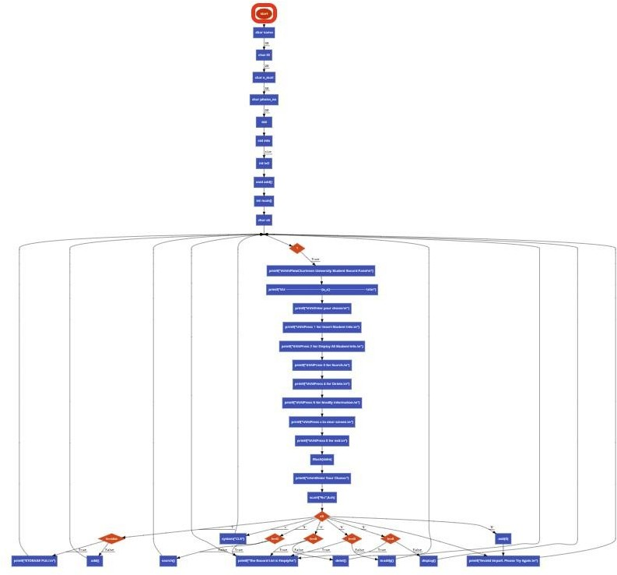

Figure 3.1: Flowchart of This Project

## Results and Discussions

#### Output

* This is the main panel of the system. From there can do any of the following option.



* If the user enter 1 then the output will be look like that:

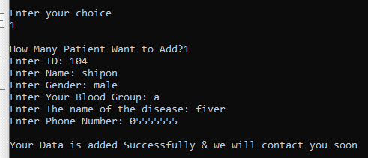

This is how we add record of a patient.

* Options 2 is for the display all the record available.

33.PNG

Those are the record of patient’s.

* Option 3 is for Search about a specific patient’s information

44.PNG

We can search using (Name/ID/E-mail/Phone_number

* Option 3 is for modify or update data of any patient

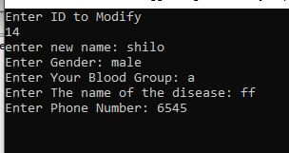

Option 5 is for modify a patient’s data

#### Analysis and Outcome

The project is build using C programming language. We do the coding on codeblocks using GCC compiler. This project is mainly built for reduce the pressure and do the work efficiently. We will update this project and add more feature. It will be helpful for all the doctor and the service provider man. So fer we do the project using the course knowledge of structured programming.

# Chapter 4 Conclusion

## 4.1 Introduction

The Doctor Appointment System needs to be computerized to reduce human errors and to increase efficiency. By computerized the system we can do the work lesser errors. This project is built for keep the information about a patient safely. And track the information quickly. And gathers all the valuable patient-related information on a single platform.

## Practical Implications

The Doctor Appointment System helps the user to easily access through all the information about patients.

## Scope of Future Work

In future this can be the most useful product in the hospital and also some places where doctor come one day in a week. It will keep the patient’s information safe and synchronized. In future we can add more feature to this. Like add results of a patient, billing history of a patient. This system can reduce the mistake and work more efficiently. In this way it can be helpful for our work.